Potomac Highlands Ladies Auxiliary
to the
Veterans of Foreign Wars of the United States
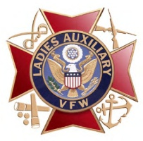

Certificate of Participation
Presented To
Petersburg High School
In Recognition of Outstanding Patriotism – Creative Patriotic Art Program

BY ORDER OF:

